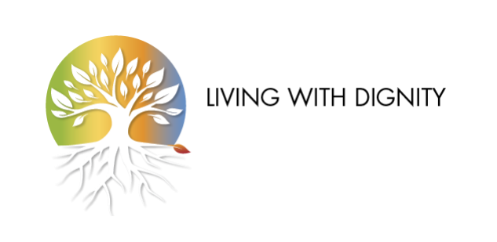

**ANNUAL REPORT 2023-2024**

**INTRODUCTION**

*Due to the adoption of Bill 11 in Quebec on June 7, 2023, this report covers the period from June 8, 2023 (rather than June 1, 2023) to May 31, 2024 (the previous report covered the period from June 1, 2022 to June 7, 2023).*

**Our efforts are bearing tangible fruit**

Since my arrival in August 2021, the period covered by this report has proven to be the most gratifying in more ways than one: a major gain in delaying a planned expansion of access to medical aid in dying (mental disorders, at the federal level), co-organization of the most important international meeting on end-of-life issues since LWD was founded, and outreach beyond all our expectations for our campaign to promote assisted living. It's hard to imagine anything better!

This annual report does not cover all our activities, but rather the main ones. For example, we were pleased to take part in *National Hospice Palliative Care Week*, but as we were not the driving force behind the excellent "Palliative Care is About Living Well!" campaign prepared by our colleagues in the *Quebec Coalition for Palliative Care Access*, we won't go into it further.

I am truly grateful to work with the Living with Dignity team. Its Board of Directors is more united than ever in advancing palliative care in Quebec, reminding us that medical aid in dying is not the solution to the suffering feared or experienced at the end of life. We are well aware that these issues are no longer confined to the end of life, and that incapacities as early as adulthood can now qualify for MAiD. What is known everywhere else as euthanasia still enjoys widespread support among the population, who still see it as a last resort, but we have to admit that this openness, voted for in Quebec 10 years ago, is leading to problems and abuses that we are discovering month by month. It's up to us to make them known.

The great strength of the Living with Dignity citizen network lies in its freedom of speech. You can count on us to exercise this freedom over the coming years, in the interests of helping people to live in Quebec, Canada and abroad.

Enjoy your reading!

Jasmin Lemieux-Lefebvre   
Coordinator   
Living with Dignity citizen network

P.S. Please do not hesitate to contact us if you have any questions while reading this document: write to us at [directionLWD@gmail.com](mailto:directionVDD@gmail.com) or call us at +1 438 931-1233.

**GOVERNANCE, ADMINISTRATION AND MANAGEMENT**

***Board of Directors***

Below is the composition of the board of directors of the Living with Dignity citizen network, as of May 31, 2024:

* Mr. Alex King - President
* Mrs Michèle Boulva - Vice-Chairwoman
* Mrs. Carmie Forlini - Secretary-Treasurer
* Dr Patrick Vinay
* Dr. Catherine Ferrier
* Dr. Paola Diadori
* Ms. Marie Bourque
* Mr. Cory Andrew Labrecque

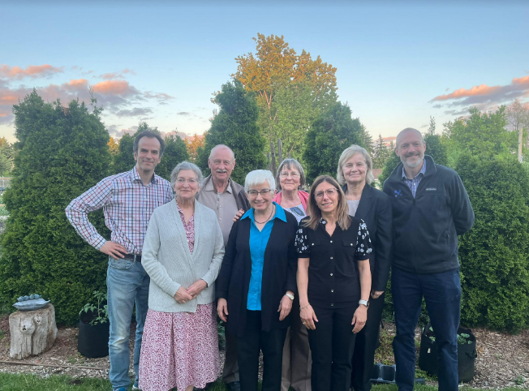

Photo taken at the May 24, 2024 Board of Directors meeting   
(Mr. Cory Andrew Labrecque was absent for excellent reasons).

For more information, visit [www.vivredignite.org/en/about-us/team](http://www.vivredignite.org/en/about-us/team).

***Coordinator***

Throughout the year, Jasmin Lemieux-Lefebvre, coordinator since 2021, was able to put his communication skills to good use at the various field meetings he attended. He represented us well in Paris, Toronto, Montreal, Trois-Rivières and Quebec City. His greatest contribution was undoubtedly the launch of the "Aid in Living" campaign, which was so close to his heart. The idea of investing in radio advertising as a springboard for the launch of a web page and a public awareness campaign was crowned with success. There's no doubt that Jasmin belongs with the Living with Dignity team.

**Financial Challenges**

The launch of the major campaign to mark the 10th anniversary of the passage of the End-of-Life Care Act (see page 3) meant that LWD did not conduct an annual fundraising campaign this year. The tradition of launching an annual campaign by mail will be maintained. In 2023, the solicitation took place in January. In 2024, it will take place in the autumn.

Before re-soliciting its allies, Living with Dignity wanted to invest part of the sums raised in 2023 in concrete actions such as the major campaign for Aid in Living. The achievements of the current year will certainly facilitate fund-raising in2024.

**10thAnniversary of the Law Paving the Way for Medical Aid in Dying in Quebec   
MAJOR CAMPAIGN TO PROMOTE AID IN LIVING**

How can we mark the 10e anniversary of the adoption of the *Act respecting end-of-life care,* on June 5, 2024? What better way than to respond to the oft-repeated wish of our allies: the creation of a tool to encourage a loved one *not* to choose medical aid in dying.

A unifying theme was chosen: **Aid in Living**.

Since it was out of the question to discuss this issue only with people who already shared LWD's point of view, a media campaign was needed to reach a wide audience.

Two media vehicles have been chosen:

a) A website: aidinliving.org

In cooperation with the entire Living with Dignity team, the LWD coordinator was able to draft the contents of a web page for the general public, giving concrete examples of how to encourage a loved one not to choose MAiD, with love and respect.

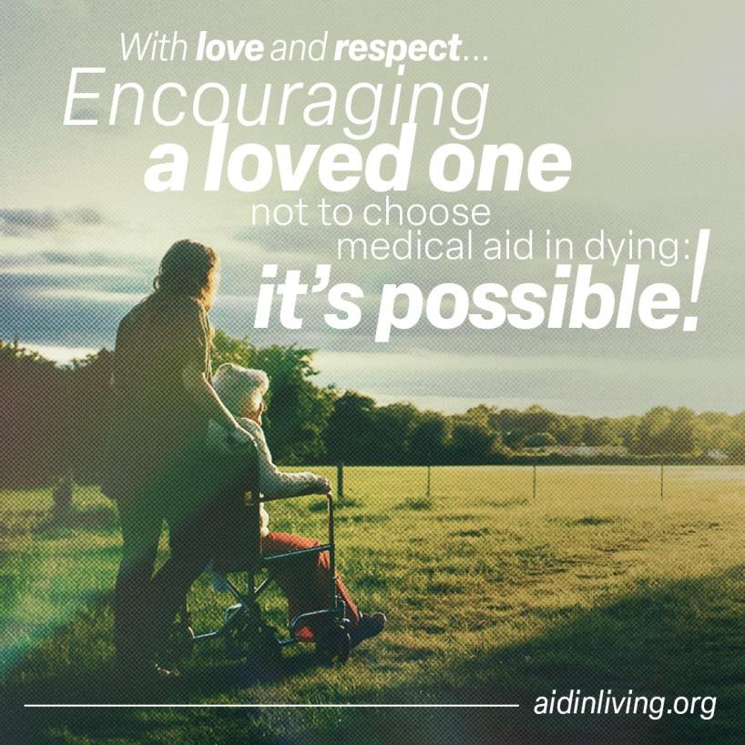

On the left, the radiant visual that will also be used on all LWD social networks.

b) A radio campaign

To directly reach Quebecers aged 50 and over, who are more likely to be able to encourage loved ones not to choose MAiD, we prioritized the radio stations in Quebec that best target them. Radio is a medium of choice, as it still offers the opportunity to enhance a campaign with free advertising for non-profit organizations.

The script for the 30-second radio publicity had first to be approved for broadcast by the various broadcasters. Below is what was proposed to them:

*10 years after the adoption ofthe law opening the door to medical aid in dying, more and more Quebecers are turning to this option to end their lives.*

*When a relative considers medical aid in dying, can we express our objection to them, with love and respect? We sincerely believe so.*

*Let's remind our family and friends that they will never, ever be a burden to us.*

*Let’s encourage an open dialogue on these end-of-life challenges.*

*To reflect on these matters with the Living with Dignity citizen network, visit*[*aidinliving.org*](http://aidinliving.org/)*.*

This message was approved without any objections.  
  
The Cogeco network was to be the backbone of the campaign, broadcasting our message on their entire network of "spoken" channels.

Montreal 98.5 CHMP

Quebec 93.3 CJMF

Mauricie 106.9 CKOB

Eastern Townships 107.7 CKOY

Gatineau 104.7 CKOF

Saguenay KYK 95.7 CKYK

and their "music" channels.  
Montreal Rythme 105.7 CFGL

Québec Rythme 102.9 CFOM

Mauricie Rythme 100.1 CJEB

Estrie Rythme 93.7/98.1 CFGE

Saguenay Rythme 98.3 CILM

Bell Media's CJAD channel would reach an English-speaking audience in Montreal, while RADIO VM would target an audience open to human, social and spiritual issues on its five stations in Montreal, Sherbrooke, Trois-Rivières, Victoriaville and Rimouski.

In all, 17 stations across Quebec aired the radio ad for one week, starting on Monday, May 13, 2024 (just after National Hospice Palliative Care Week, May 5-12, 2014).

To hear the radio commercials :  
  
- in English: https:[//youtu.be/2QXqueQ_HGU](https://youtu.be/2QXqueQ_HGU)  
 - in French: https:[//youtu.be/9Tz7VXXKfxg](https://youtu.be/9Tz7VXXKfxg)

**Campaign impact**

This operation gave Living with Dignity its greatest public visibility since its creation in 2010. Without press coverage, it was already delivering its message to combined audiences reaching hundreds of thousands of Quebecers. Given the media's reluctance to cover anything that calls into question track 1 of access to medical aid in dying (which the law initially authorized at the end of life for cases of terminal illness), LWD felt it was important to invest in an advertising approach that would ensure it reached its target audience directly.

Living with Dignity is also delighted with the media coverage, which took place in three stages:

**1) Campaign launch on May 13**  
 After sending out a press release (read it at <https://vivredignite.org/en/com-campaign-aidinliving>), two opposing pieces of press coverage:  
  
 a) Critical of the very idea of the Campaign :  
Continuous news channel LCN, interview by Michel Jean with the LWD coordinator, at 25:24 <https://www.tvanouvelles.ca/videos/6352853632112>  
  
 b) Open to the arguments put forward:  
Bulletin ICI Québec de 18h, interview by Bruno Savard with LWD coordinator <https://ici.radio-canada.ca/info/videos/1-8940628/une-campagne-pour-amener-une-reflexion-sur-soins-fin-vie>  
  
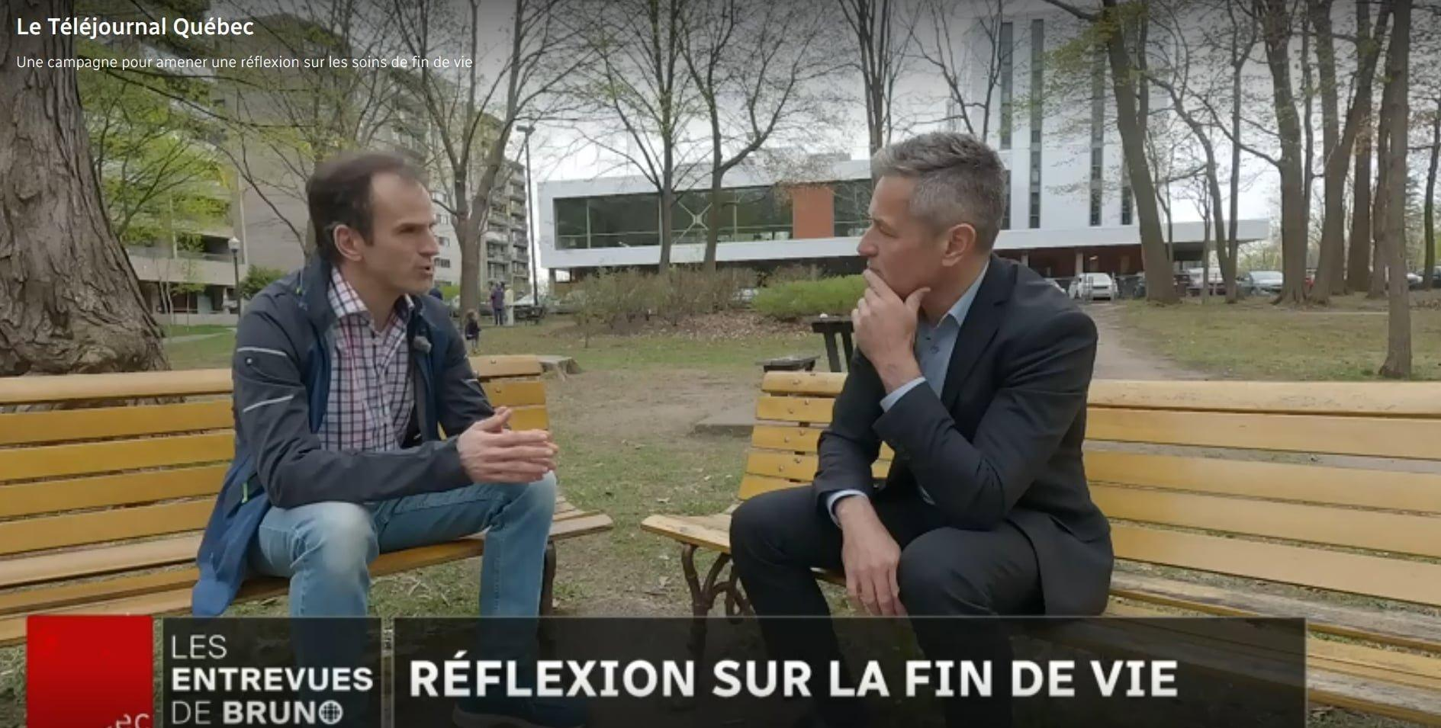  
  
**2) In a series of columns and a reply in La Presse**

On Thursday, May 16, Patrick Lagacé, one of *La* Presse's most important columnists and a radio host on 98.5 FM (one of the stations where the radio ads were broadcast) published a column in which he denigrated the campaign and the LWD citizen network ("a religious group" according to him, which he refused to name):

*Leave the dying alone (and love them)*<https://www.lapresse.ca/actualites/chroniques/2024-05-16/fichez-la-paix-aux-mourants-et-aimez-les.php>  
Immediately, the next morning, LWD issued this press release <https://vivredignite.org/civicrm/mailing/view/?id=983&reset=1>  
 and requested a reply from the editorial team at La Presse.

The next day, La Presse published this response to Mr. Lagacé's column, signed by LWD's coordinator:

*Dare to talk about assisted living in Quebec*

<https://www.lapresse.ca/dialogue/opinions/2024-05-17/replique/osons-jaser-au-quebec-de-l-aide-a-vivre.php>  
  
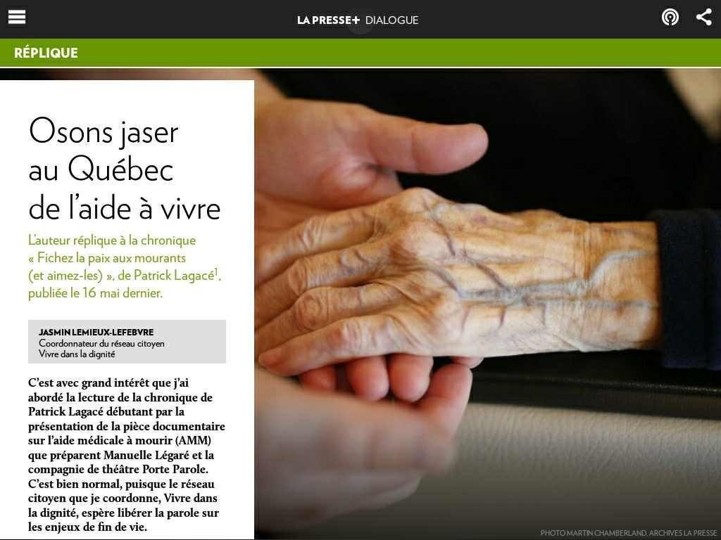  
  
The columnist refused a face-to-face exchange and exercised his right of reply two days later in a column entitled "Des amis personnels de Jésus" ("Personal friends of Jesus"), which listed all the members of the Board of Directors and attempted to insinuate that their personal faith makes LWD a religious group rather than a citizens' network, without ever dwelling on the arguments put forward by the Aid in Living Campaign.  
<https://www.lapresse.ca/actualites/chroniques/2024-05-19/des-amis-personnels-de-jesus.php>  
  
This high level of visibility will enable LWD to receive messages of support from all walks of life, and to rally the team around its civic mission.

**3) In interviews broadcast around the 10e anniversary of the Act**

Two longer radio interviews were given by the LWD coordinator in conjunction with the 10th anniversary of the *End-of-Life Care Act*. Although they were broadcast after the period covered by this report, they are direct fruits of the Campaign:

June 6th with Jean-Philippe Trottier on "Questions d'actualité", Radio VM <https://youtu.be/sLZojAejQiU>  
  
June 11th with Yves Houde on "Entre-nous", Radio Galilée  
<https://youtu.be/ixuJgo2Wmdw>

Several other mentions of the Campaign were heard on the radio, and it was picked up on the web and social networks by a host of observers.  
  
Two examples:  
  
May 16th - Quebec: a campaign to prevent "medical aid in dying"   
Alliance Vita  
<https://www.alliancevita.org/2024/05/quebec-aide-medicale-a-mourir/>  
  
May 29th - Medical aid in dying: can we discuss a personal decision?  
Laurence Godin-Tremblay - Le Verbe Médias  
<https://le-verbe.com/opinion/aide-medicale-a-mourir-peut-on-discuter-dune-decision-personnelle>

**Solidarity Between Groups Seeking Alternatives to Euthanasia   
INTERNATIONAL CONFERENCE ON THE END OF LIFE**

  
In November 2023, LWD was invited by Caroline Roux, Deputy General Delegate and Director of *VITA International*, to co-organize an international meeting on the end of life in conjunction with the *European Institute of Bioethics*, based in Belgium. After reflecting on the issue at a meeting of its Board of Directors, it was quickly decided by LWD to accept the offer and to ensure that the February 28 event in Paris would be a great success.

Living with Dignity's first contribution was to help program the event by identifying and contacting three key people who would agree to participate alongside the LWD coordinator.

On site:

* Trudo Lemmens, Professor of Health Law and Policy (University of Toronto, Canada);

Remote:

* Leonie Herx, palliative care physician, clinical professor (University of Calgary, Canada);
* Shane Macaulay, physician in Washington State, USA, and past president of the Washington State Medical Association.

In the run-up to and during the event, LWD helped bring a North American perspective to the international gathering. The videos and the entire day's content are available at:[www.rencontreinternationalefindevie.org](http://www.rencontreinternationalefindevie.org) and the Canadian summary in English) at <https://vivredignite.org/en/2024/03/intl-meeting-paris-2024>.

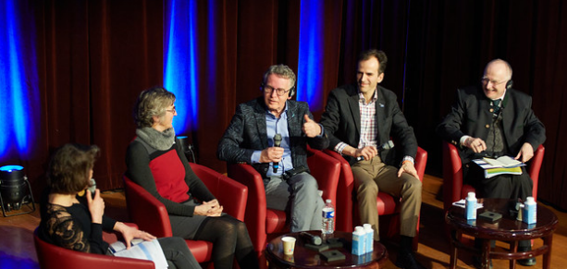

The official event press release provides a good summary of the content presented during the day (in French):  
<https://www.alliancevita.org/2024/03/cp-rencontre-internationale>  
  
 Extract: *Alliance VITA spokesman Tugdual Derville summed up the "precious warnings" issued to France by experts from the countries concerned: against "all naivety" in the face of the "inescapable irradiation of the whole of society" induced by the lifting of the ban on killing, the "so-called 'freedom' to die [being] in reality liberticidal".*

*He concluded the meeting with these words: "When the accelerated death of dependent, sick or elderly people is presented as a solution, a good, a form of despair in the face of vulnerability inexorably creeps into people's minds. And the first victims of this despair are the most fragile people, threatened by suicide - in all its forms - and euthanasia."*

Since then, a book has been published, compiling all the information shared at the meeting <https://www.alliancevita.org/wp-content/uploads/2024/05/Euthanasie-Suicide-assiste_Retours-dexperience-de-letranger.pdf>  
  
Also worth listening to is this interview with the LWD coordinator during his visit to Paris, on Radio Notre-Dame:  
*L'invité de la Rédaction - Quebec, ten years after the legalization of euthanasia*  
<https://youtu.be/U0mpMgzHPPw?si=sPBF9z9FxsdrQ_hh>

**PARTICIPATION IN OTHER NATIONAL AND INTERNATIONAL EVENTS**

In addition to the International Meeting in Paris, co-organized by LWD, the LWD coordinator participated in three other events:

*Medical aid in dying in Quebec: 10 years later*Scientific event presented at the CHUM in Montreal on April 24, 2024  
<https://www.eventbrite.ca/e/billets-aide-medicale-a-mourir-au-quebec-10-ans-plus-tard-818575129247>

*Dare to hope!*2024 Congress of the Association québécoise de soins palliatifs May 2 and 3 in Trois-Rivières  
<https://www.aqsp.org/24e-congres/congres-2024-a-trois-rivieres>

*Towards a testimony of Hope*International interfaith symposium on palliative care  
<https://www.eventbrite.ca/e/billets-symposium-international-interconfessionnel-sur-les-soins-palliatifs-814198578867>

Each gathering has provided a multitude of interesting encounters to exchange both with our natural allies and with those who do not share LWD's point of view (including several medical aid in dying providers). Each time, LWD presents its conviction that there are always better options than MAiD for ending one's life, all the while conversing with experts and volunteers in a spirit of constructive dialogue. 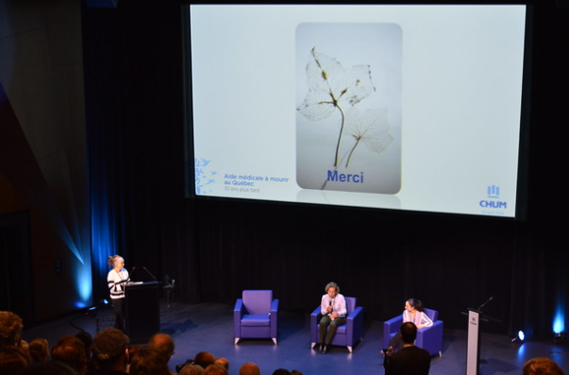

Efforts are made to ensure that LWD stays in contact with those encountered at such events.

**PROVINCIAL POLITICAL SCENE**

In the summer of 2023, LWD issued a press release (see page 18) welcoming the publication by the *Commission sur les soins de fin de vie* of reminders to Quebec physicians practicing MAiD. Therein, the Commission outlined the problems associated with the non-compliance of an increasing number of cases of medical assistance in dying, the shopping around for a favorable opinion and the fact that aging is not an eligibility criterion for MAiD.

The publication of the Commission's annual report on October 24, 2023 led to a new reaction from LWD (see page 18).  
  
*Excerpt: 5,221 Quebecers received medical aid in dying between April 1, 2022 and March 31, 2023. This represents an increase of 42%, or 6.8% of deaths, which sadly places Quebec in first place worldwide. The 23 cases of non-compliance listed in the report are cause for concern. Each case of non-compliance is one too many, and the Collège des médecins du Québec (CMQ) has yet to sanction any of its members in respect of cases of non-compliance in the administration of medical aid in dying (since 2015);*

Another issue: this spring, the Government of Quebec lobbied the Government of Canada to amend the Criminal Code to allow for the implementation of a regime of medical aid in dying by advance request. Given the federal government's refusal to embark on such a legislative project, it will be interesting to see what Quebec's next move will be.

In March, Madame Sonia Bélanger, Minister Responsible for Health and Seniors confirmed an important research to be carried out on MAiD: Marie-Ève Bouthillier and her team from the Université de Montréal's Bureau de l'éthique clinique received a grant of close to one million dollars over three years from the Fonds de recherche du Québec - Société et culture, in order to better understand the reality in Quebec and compare it with that elsewhere in the world".

Living with Dignity will want to participate in this research in one way or another, and an initial pitch has already been made to the research team.

**FEDERAL POLITICAL SCENE**

From the fall of 2023 to the end of February 2024, we worked with allies across Canada to block the planned access to MAiD for mental health cases as early as March 2024. Whether during the debates surrounding Bill C-314 or during the work of the AMAD committee (see press releases on page 18), which led to the recommendation to postpone this expansion until 2027, LWD worked hard behind the scenes and in the public arena to make its point.

Reference is made to the brief presented by LWD to the AMAD committee (max 100 words) [https://www.ourcommons.ca/Content/Committee/441/AMAD/Brief/BR12725836/br-external/LivingWithDignity-f.pdf](https://www.ourcommons.ca/Content/Committee/441/AMAD/Brief/BR12725836/br-external/LivingWithDignity-f.pdf%20) and to the decision to postpone the widening of access to MAiD.

Listen to: Genevieve Beauchemin at 10:48 on CTV News Montreal ,January 30, 2024 at:

<https://montreal.ctvnews.ca/video/c2851983-ctv-news-montreal-at-six-for-tuesday--january-30--2024?binId=1.1810301>

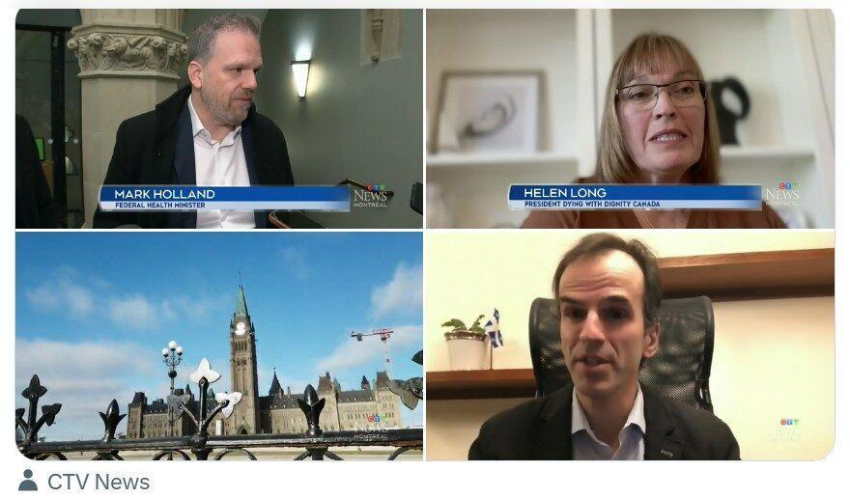

The adoption of Bill C-62 on February 29, which officially defers the extension of eligibility for MAiD until March 17, 2027, is a great victory for the Canadian movement questioning MAiD and its extensions. But there is still a long way to go before the measure is permanently abandoned. Attempts to legalize other openings to MAiD, such as that of the Bloc Québécois with its bill on early applications (see LWD press release on page 18), are to be expected.

**ONLINE PRESENCE**

An active presence on social networks continues to be a hallmark of LWD. Below is a summary of our activities in this area over the past year.

***Social media***

The following are a few statistics on the use of our *X* and *Facebook* accounts and, new for LWD, our *LinkedIn* account. This recent presence is modest (50 posts, 85 subscribers), but it allows us to network with professionals not found on other networks.

***X (formerly Twitter)***

857 subscribers (including several journalists, politicians and opinion leaders) -   
705 in 2022-2023.

June (8-30) 2023: FR 30 tweets + EN 3 tweets = 33  
July 2023 : FR 12 tweets + EN 4 tweets = 16

August 2023 : FR 25 tweets + EN 8 tweets = 33

September 2023 : FR 36 tweets + EN 5 tweets = 41

October 2023: FR 46 tweets + EN 10 tweets = 56

November 2023: FR 38 tweets + EN 6 tweets = 44

December 2023 : FR 17 tweets + EN 6 tweets = 23

January 2024: FR 18tweets + EN 7 tweets = 25

February 2024 : FR 37 tweets + EN 7 tweets = 44

March 2024: FR 36 tweets + EN 10 tweets = 46   
April 2024 : FR 14 tweets + EN 3 tweets = 17  
May 17, 2024 : FR 11 tweets + EN 7 tweets = 18

Number of tweets (excluding retweets): 396 (the figure of 772 tweets in 2022-2023 included retweets). The most popular tweet, with 3,932 views, was published on May 13, 2024: https:[//x.com/Vivredignite/status/1789976771791573347](https://x.com/Vivredignite/status/1789976771791573347)  
  
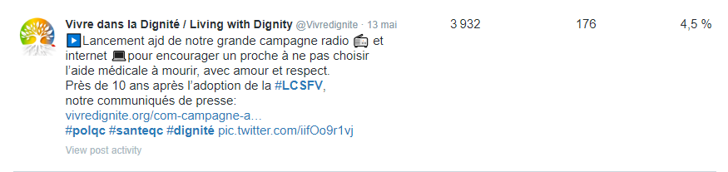

***Facebook***

980 "Like" mentions (922 in 2023-2024), 1,000 accounts follow the page (986 in 2023-2024)

*In brackets are the number of posts in French (left) and the number of posts in English (right).*  
June 2023 (8 to 30): 9 posts (9, 0)   
July 2023 : 9 posts (8, 1)   
August 2023 : 9 posts (8, 1)   
September 2023: 10 posts (8, 2)   
October 2023 : 21 posts (16, 5)   
November 2023 : 12 posts (10, 2)   
December 2023 : 5 posts (4, 1)   
January 2024: 9 posts (6, 3)   
February 2024: 9 posts (7, 2)   
March 2024: 7 posts (5, 2)   
April 2024: 13 posts (11, 2)   
May 2024: 19 posts (16, 3)  
  
Total: 132 posts (220 in 2022-2023)

LWD has reduced the number of its Facebook posts due to new Meta rules that prevent the publication of media content and an algorithm that makes it harder to reach friends/users who follow the page.

Most popular Facebook post of the year:

1,502 users reached following the share of May 13, 2024  
  
<https://www.facebook.com/vivredignite/posts/pfbid0qaEecQVPavL5SK6xSzXhWpEgp8PAEoZJcrzpuijYNXRrmiDPD4GHdU9NF2PLigxpl>  
  
 See the visual on the next page.

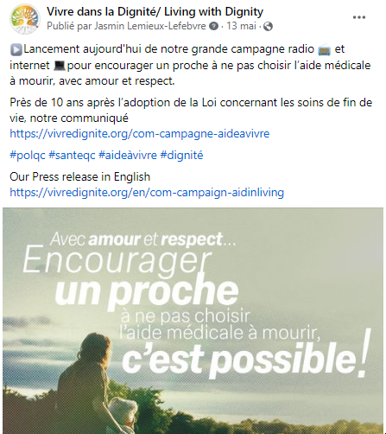  
  
  
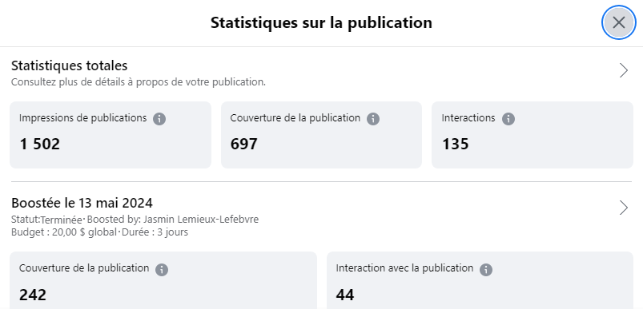  
  
  
LWD will continue to comment on other Facebook posts to share its views on issues close to the citizen network's heart.

***Website***

Our website <http://www.vivredignite.org/en>has not changed its appearance this year, but technical support has enabled us to iron out a number of bugs. A new freelance webmaster helped LWD to create the [www.aidinliving.org](http://www.aidinliving.org) page (see page 3), and will now take over development of the corporate page.

The LWD website published many more articles this year, more than double the number of the previous year: 25 articles in French and 24 in English, for a total of 49 articles this year (24 in 2022-2023).

***Emailing***

LWD subscribers also received twice as many e-mails: 46 (23 in French, 23 in English) compared with 24 in 2023-2024. The decision to publish a weekly press review starting on September 18, 2023 resulted in 34 newsletters (17 in French and 17 in English), compared with four in 2022-2023. Frequency decreased during the intense work periods leading up to the two major projects of the year (the International Meeting and the Advertising Campaign), but LWD's allies seem to appreciate receiving information by e-mail that is more difficult to receive via social networks (such as Facebook) due to algorithmically limited sharing.

**MEDIA**

Living with Dignity has shared seven press releases in the last 12 months (four in 2023-2024):

* August 7, 2023 - *Memo to Quebec physicians practising MAiD – The Commission on end-of-life care had to act*

<https://vivredignite.org/en/pr-memo-to-qc-physicians-maid>

* October 20, 2023 - *Close vote outcome on Bill C-314 in Ottawa - Strong transpartisan opposition to Medical Assistance in Dying for mental disorders*   
  <https://vivredignite.org/en/com-october-20-2023>
* October 26, 2023 - *The “exceptional intervention” that is not exceptional –  
  new MAiD reports in Québec & Canada*<https://vivredignite.org/en/com-october-26-2023>
* January 30, 2024 - *Proposed deferral of Medical Assistance in Dying for Mental Disorders: Celebrating with Caution*  
  <https://vivredignite.org/en/com-january-30-2024>
* May 13, 2024 - *Major radio and Internet campaign to encourage a loved one not to choose medical aid in dying, with love and respect - 10 years after the adoption of the Act respecting end-of-life care*<https://vivredignite.org/en/com-campaign-aidinliving>
* May 16, 2024 –(only in French) *Strong reaction to a column in La Presse denigrating the Living with Dignity citizen network and its Aid in Living campaign*  
  <https://vivredignite.org/civicrm/mailing/view/?id=983&reset=1>
* May 22, 2024 - *Living with Dignity’s reaction to the Bloc Québécois Bill and a Coalition’s approach - The boundary of incapacity: one that must not be crossed*<https://vivredignite.org/en/com-may-23-2024>

These press releases (almost always available in English) remind journalists that LWD is a valuable resource for providing a counterweight to messages that promote medical aid in dying in the public arena, while reminding them of the treasure of palliative care (a term dear to LWD).

In addition to our presence in the media noted in previous sections of this report, an additional interview with the LWD coordinator took place on January 26, 2024 with the *Le Verbe médias* team, on their program *Les Verbomoteurs:*

*How to dissuade a loved one from seeking medical assistance in dying?*<https://www.youtube.com/watch?v=7nwWwXAHRww>

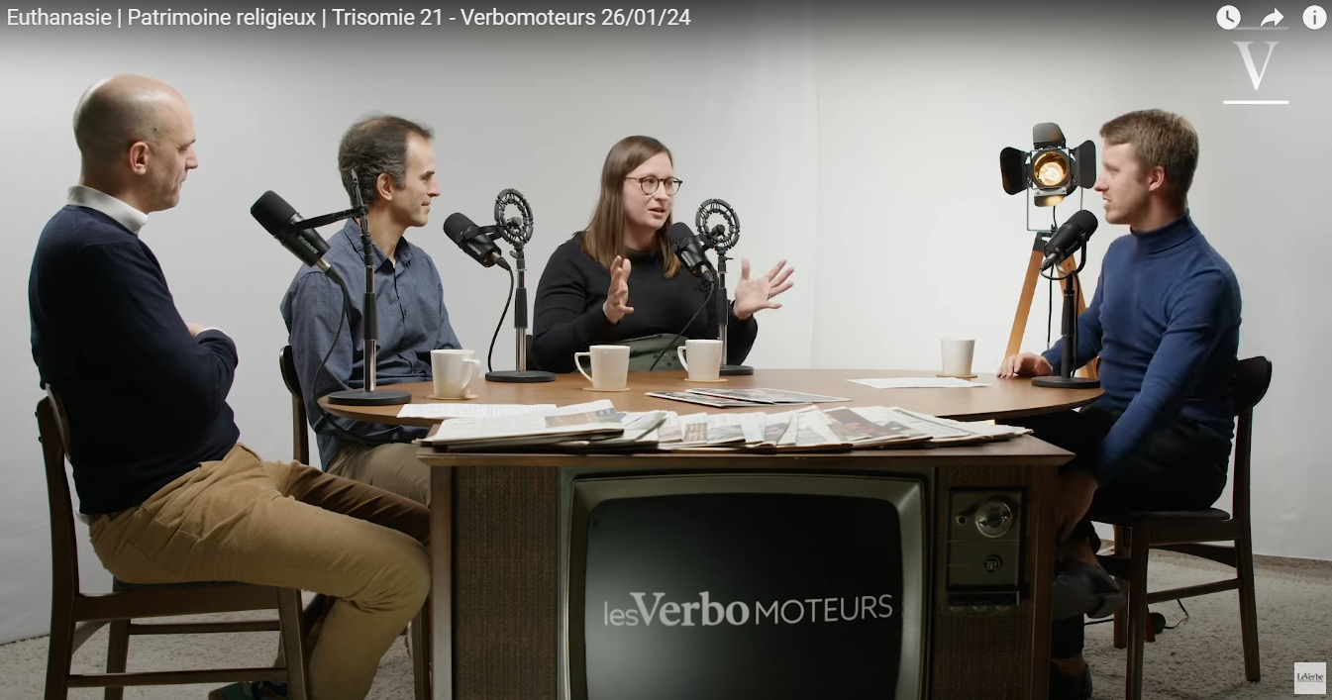

**FUTURE PROSPECTS**

With a deadline of June 7, 2025 for the implementation of medical aid in dying by advance request, this theme is sure to feature prominently on the agenda of Living with Dignity over the coming year. An informal think tank we helped create is actively identifying ways to highlight the multiple issues associated with administering MAiD without contemporary consent.

On October 7, we'll be taking part in a National Summit on Disability (the first in 40 years!) at Université Laval. A great opportunity to bring together a host of resources that promote assisted living.

It will be interesting to find other tools to communicate the content shared on our aidinliving.org page. Many allies have asked us for printable tools, which we plan to produce over the coming months.

Fall will also see the launch of our annual fundraising campaign, which will focus on both financial donations and the importance of inviting friends and family to join our civic network.

On the international front, there are bound to be surprises in store, as France and Great Britain may introduce bills paving the way for a form of assisted dying/euthanasia/assisted suicide. The team from *Envoyé spécial* (*France 2*'s public affairs program, which passed through Montreal in the spring) is preparing a report to which we will want to respond.

More than ever, we hope to be at the forefront of reminding people of the intrinsic dignity of all human life. With love and respect.