ANNUAL REPORT 2021-2022

OVERVIEW OF THE YEAR

Throughout the period covered by this report (June 1st, 2021 to May 31st, 2022), expanding access to medical aid in dying has been on the political agenda of our decision-makers, both in Quebec and in Ottawa. The process has taken us from a Quebec Commission to a Federal committee and to debates surrounding a major provincial bill.

We have many reasons to celebrate the fruits of our efforts this year: a victory on the issue of medical aid in dying and mental illness at the provincial level, renewed media attention for our messages after years of being blocked, a ten-fold increase in our active presence within the Coalition for Access to Palliative Care, and many other elements that you will discover in this annual report.

The challenges are still very great, and our resources are drastically less than those of groups advocating for new access to medical aid in dying.

We are proud of our fundraising campaign Supporting Dignity in Adversity, but its results only allow us to continue in our current mode of operation, with a coordinator, productive alliances, a network of volunteers and a lot of creativity.
Even with minimal numbers, we are able to give wings to rational arguments to oppose the abuses associated with medical aid in dying in its current form and against the arguments of those who want to make it accessible to as many people as possible.

Needless to say, we look forward to the day when we are financially able to add another employee to our team.

GOVERNANCE, ADMINISTRATION AND MANAGEMENT

Board of Directors
The stability of our Board of Directors is a source of pride for LWD. Year after year, we maintain a strong core while knowing how to renew ourselves.
Here is the composition of the Board of Directors as of May 31, 2022:
- Mr. Alex King - Chair
- Mrs. Michèle Boulva - vice-president
- Ms. Carmie Forlini - Secretary-Treasurer
- Dr. Patrick Vinay
- Dr. Catherine Ferrier
- Dr. Paola Diadori
- Ms. Marie Bourque
- Mr. Cory Andrew Labrecque
You will note only one change in the past year. At the meeting of the Board of Directors, on November 24, 2021, its members confirmed the appointment of Ms. Carmie Forlani as Secretary-Treasurer. We are very happy to count on her expertise.
Carmie Forlini holds a Bachelor of Commerce degree from Concordia University. She has over 35 years of corporate experience in human resources and accounting and had her own bookkeeping business for 15 years. She has also been a certified life coach since 2014, helping her clients maximize their potential while navigating personal and interpersonal conflicts. She joined Living with Dignity because she firmly believes that every life is precious, from conception to natural death.
"Every life deserves to be lived with dignity to the end and Living with Dignity is determined to fight for that," she shared with us.
Mrs. Forlini replaces Mrs. Odile Marcotte who has been a member of our Board of Directors since its inception, for 12 precious years. We thank her for her valuable services and are very pleased that she will continue her commitment to LWD as a volunteer.

Coordinator
For the past two years, we have been privileged to have an outstanding coordinator. Jasmin Lemieux-Lefebvre is a seasoned communicator who is respected by his peers and the media community. His in-depth knowledge of the issue at hand, as well as his impressive leadership, place LWD at the heart of the resistance to the problems caused by a so-called right to medical aid in dying for an ever-increasing portion of the population. This report is a good example of his creativity and initiative.

Financial challenges
As planned, we conducted a fundraising campaign in the Fall of 2021. This followed the negative response from the Canada Revenue Agency (CRA) to our application for charitable status (February 2021, see our 2020-2021 Annual Report).
The theme of the campaign was
I Support Living with Dignity in Adversity.
A message from our President accompanied the fundraiser in all its forms:

Dear all,
After more than a decade of representing you in the public arena (our founding dates back to May 2010), LWD remains more relevant than ever in the Quebec and Canadian landscape. Current events tragically confirm this. At the heart of all the debates on the expansion of access to “medical assistance in dying / MAiD” (Bill C-7 at the federal level, a Select Committee at the provincial level, etc.), Living with Dignity remains the most active group in Quebec denouncing the many abuses of euthanasia.
With your help, we are pursuing our mission: “to promote the protection of life, the inherent dignity and accompaniment of people made vulnerable by illness, old age or disability”, while proposing “The Treasure of Palliative Care” as evidenced by our new video series. If you haven’t seen it yet, check it out at vivredignite.org/treasure. Your donations make it possible for us to produce such heart-touching tools !
The Treasure of Palliative Care is designed to respond to those who claim that medical aid in dying is part of palliative care (!) and to support those hospices that still refuse to administer MAiD. Remember that they are now part of a brave minority in Quebec (only 18 out of 37 hospices do not offer it). The video series was produced in both English and French, paying tribute to one of Canada’s pioneers in the field, Dr. Balfour Mount, who called it “excellent”. We have shared the series around the world, knowing that many of our international allies will benefit from it.

For the first year, we are releasing an abbreviated version of our annual report via vivredignite.org/2020-2021. In it, we discuss the rejection of our application for charitable status. A surprising decision, to say the least, considering the fact that Dying with Dignity Canada has obtained this status. A flagrant injustice that prevents us from issuing you a tax receipt for your donation.

In addition, the Association québécoise pour le droit de mourir dans la dignité now receives an annual grant from the Quebec government ($123,545). There is now a profound imbalance of resources between us and the advocates of expanded access to euthanasia who can count on full-time staff to advance their ideas. Our current funding only allows us to hire a part-time coordinator. We are grateful to all the volunteer resources at the heart of our mission, but their availability is obviously limited to carry out our goals.

We refuse to give up in the face of the steamroller of the trivialization of euthanasia. Against all odds, we are proud to represent you in reminding all people that the loss of physical or mental faculties never implies a loss of dignity.

In the face of adversity, thank you for supporting us in a special way this year,
Alex King, President

We solicited our allies through personalized mailing, email and social media.
Unfortunately, our Facebook campaign did not get a “boost” from the advertising, as it was rejected due to its political content (see bottom of image, in French, Rejetée: Rejected).
During this campaign, we received 175 donations totaling $24,438.
Note that we have discontinued our annual membership program ($20 per year). After analysis, we decided that we would prefer to motivate our donors to give more rather than offer them a "floor donation".
We hope to reach out to our allies again in the Fall of 2022. In addition to mailings sent out to individuals in our database, we will also reach out to potential major donors in groups and institutions.
PROVINCIAL POLITICAL SCENE
Spreading our ideas
Work of the Select Committee on the Evolution
of the Act respecting end-of-life care

As referred to in our 2020-2021 annual report, the Select Committee on the Evolution of the Act respecting end-of-life care continued its hearings in August 2021. Its mandate: to study the potential extension of medical aid in dying to people who are incapacitated (caused by a neurodegenerative disease such as Alzheimer's) and to those whose only medical problem is a mental disorder.
After having shared a brief with the Committee, it was on August 9th, that we were able to express ourselves directly to the Committee members through our coordinator Jasmin Lemieux-Lefebvre and Julie Senécal, a citizen living with mental health challenges. The presentation (10 min.) was followed by a question period (35 min.). We are very happy to have been able to adopt a complementary approach that presented our ideas first, followed by Julie's strong testimony, summarized here in a few words:
I am Julie Senécal, 48 years old, mother of 4 daughters, trained as an epidemiologist. Place of residence, the Outaouais. In 2013, I sank into a major depression that lasted 8 years, and I am still fragile, despite therapies, and (poorly) available resources. During these 8 years, I was hospitalized 5 times for suicide attempts (...) During this period of intense distress, with no resources available, if medical aid in dying had been offered to me, I would have signed "yes", seeing no other way out. Today, I finally have the chance to be well taken care of (medically: psychiatrist, family doctor, and socially: social workers, psychologists, support groups) and I can enjoy life and my 4 children with happiness.
I have regained my ‘joie de vivre’.
However, I needed help and guidance to get there, over several years.

The brief and the video of the hearing are available on our website:
https://vivredignite.org/lwd-select-committee-2021

As planned, we took this opportunity to pre-launch our video series, The Treasure of Palliative Care, to make it accessible for the Committee members.

On each day of the hearings, we continued our efforts to network with those who share our beliefs. We also continued the tradition of sharing the Committee's daily schedule of interventions on our Twitter and Facebook pages, tagging the various speakers where possible. In this way, our publications have been shared/viewed/liked by stakeholders from all walks of life.

Our working groups have continued to be useful throughout our efforts to share information and ensure that our interventions remain complementary.

An important victory
Submission of the Report of the Select Committee on the Evolution of the Act respecting end-of-life care

When the report was tabled on December 8th, 2021, we were pleasantly surprised by the Committee members' decision not to recommend extending access to medical aid in dying to people whose only medical problem is a mental disorder. In our joint press release with the Physicians Alliance against Euthanasia, we were careful to contain our joy. It had been years since our movement had achieved a political victory. It is of course the fruit of teamwork and the courage of several new figures who dared to speak out during the proceedings. No one could pretend that it is always the same people or groups who oppose the expansion of euthanasia in this country.

Unfortunately, this celebration was tinged with concern, because the Committee also recommended opening the door to medical aid in dying through advance directives, for people who are inapt. This would most certainly become our prime subject of concern in the coming months.
We took advantage of this day to launch the first videos in our video series Expanding Access to Medical Aid in Dying? with Louis-André Richard, which we present in the Video Productions section.

Initiative that was set aside by the Quebec government but which will return:
Bill 38 amending the "Act respecting end-of-life care and other legislative provisions

Following the tabling of the Committee's report, the government announced that a Bill would soon be tabled. We had to wait until May 25th to see Bill 38, amending the Act respecting end-of-life care and other legislative provisions. In addition to wanting to amend the Federal Bill C-7 by including neuromotor disability as an eligibility criterion and to extend access to medical aid in dying by advance request, to people who are inapt, this Bill contained a very unpleasant surprise: the obligation for hospices to offer medical aid in dying, "with certain exceptions”.
The Quebec government thought it could rush the Bill through at the end of the parliamentary session, but this strategy backfired. After a setback on the issue of disability (withdrawn from the Bill), the Bill died on the order paper during its detailed study, due to a lack of time for adequate debate. How fortunate!

Living With Dignity was one of the first to react with a press release on the day the Bill was introduced. This communication gave us a great showcase on the LCN all-news channel on May 29th (see Media section). We had been waiting for this moment to share the rest of the videos in the series Expanding Access to Medical Aid in Dying? series, including the flagship video Living and Dying with Dignity (see Video Productions section).

A few days later, on June 1st, in response to the Government's decision to hear witnesses for only one day of hearings, we issued another Press Release. Of all the invited witnesses, only one group opposed part of the Bill: the Association des Maisons de soins palliatifs du Québec (regarding the obligation of their members to offer MAiD).

Here is our President’s statement in light of this choice:
It is one thing to rush a Bill through by June 10,
but to rush it through while completely ignoring all of the experts who oppose the most significant expansion since the adoption of the law concerning medical aid in dying seems inconceivable. We still hope that the Committee will invite new experts to complete its consultations on the historic frontier of induced death of inapt persons by advance request.

- Statement by Mr. Alex King,
President of Living with Dignity Citizen's Network

It is disconcerting to note that the leading figure of the opposition to the extension of MAiD for inapt persons, geriatrician and expert Félix Pageau, was not invited to the hearings.

We were very proud to have a video series produced with Dr. Pageau, entitled Incapable of dying by advance directive, ready to be launched. We posted the four videos in the series online the same day, in French and English, to allow his perspective to shine through.
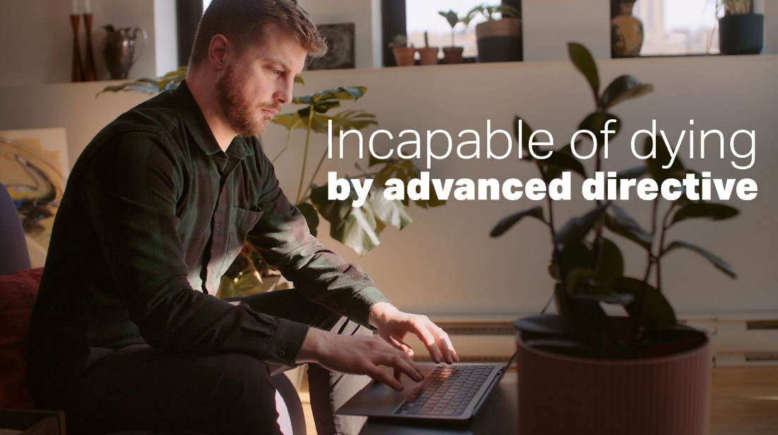
Despite the fact that this annual report covers the period ending on June 1st, 2021, we felt it important to share with you, the conclusion of a private member's initiative on June 9th.
During the short study of the Bill, we followed and commented live on the committee's work through our social networks. We accompanied the publication of opinion letters. Two of them were published on the morning of June 9th:
Human dignity, a bulwark against dementophobia, by Félix Pageau (the resource in our video series)
Bill 38: Rather than anticipating death, choose to love and be loved
by Thomas De Koninck, Professor Emeritus, Faculty of Philosophy, University of Laval.

A few hours later, the Government decided to close the detailed study of the bill, confirming that it would not be adopted before the end of the legislative session. At the same time, it announced that the bill would be reintroduced after the October 3, 2022 provincial election.

FEDERAL POLITICAL SCENE

A long-awaited review
The Special Joint Committee on Medical Assistance in Dying
"The statutory review of the medical aid in dying provisions of the Criminal Code and their application" began on April 13th, 2022. The Special Joint (Senate and House of Commons of Canada) Committee on Medical Assistance in Dying (AMAD, the name of the committee) was scheduled to meet a deadline of June 23rd to prepare its report. Given the impossibility of the task, the deadline was quickly extended to October 17th, 2022.

With our allies, we understood that the number of witnesses would be much smaller than for other consultations. In this context, we chose to submit the names of individual experts rather than organizations such as ours, which can be likened to pressure groups.
We were very disappointed to see that all groups advocating for the expansion of medical aid in dying had received invitations (Dying with Dignity Canada, Quebec Association for the Right to Die with Dignity), but not those groups opposing it. Despite our efforts, we have never received an invitation, a first since the beginning of parliamentary consultations on the subject in 2010 (Dying with Dignity Commission), both at the provincial and federal levels.
Nevertheless, we produced a brief (the tight deadline of only a few days and the specified maximum number of words limited us in our intervention) and chose to share the testimonies of all the experts who expressed reservations about the expansions explored by the Committee.
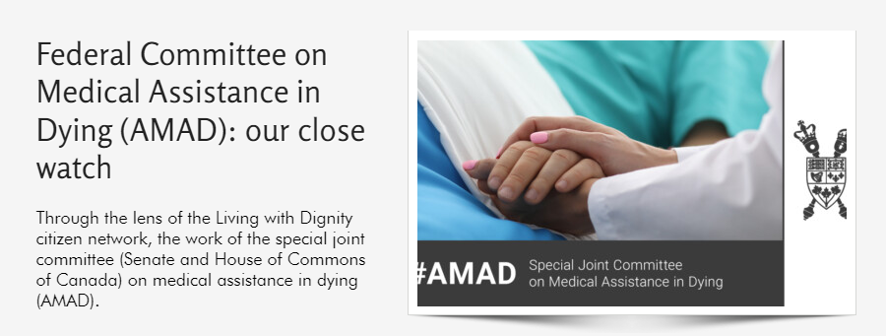
In addition to sharing these stories on our social networks, we have indexed them on our website https://vivredignite.org/amad-committee-watch.
We tried to contact these experts by email or social networks to thank them for their interventions and to keep in touch.
Credibility questioned
Expert Panel on MAiD and Mental Illness

Bill C-7 of March 2022 "temporarily excludes, until March 17th, 2023, eligibility for MAiD for individuals for whom mental illness is the only underlying medical condition. In the legislation, an expert panel on MAiD and mental illness was to be formed to conduct "an independent review of the recommended protocols, guidelines and safeguards for requests for medical aid in dying for persons with mental illness.
The Committee's report was tabled on May 13th, 2022, without attracting media attention. The absence of recommendations for robust safeguards specific to MAiD in cases of mental illness surprised many. Living with Dignity denounced the panel's lack of objectivity as early as March 3rd, when the chair of the expert panel, Dr. Mona Gupta, signed an open letter opposing the decision of the Quebec Select Committee not to open the door to MAiD for cases of mental illness. Moreover, she did so by co-signing with one of the most ardent advocates of MAiD expansion, Professor Jocelyn Downie.

Note: Quotes about the panel and their full report can be found on this page.
COALITIONS AND CONSULTATION
Quebec Coalition for Access to Palliative Care
On November 17th, 2021, a meeting of the members of the Quebec Coalition for Access to Palliative Care was held. It was the first face-to-face meeting since the beginning of the Covid-19 pandemic.

The Coalition describes itself as follows:

Since 2018, the Quebec Coalition for Access to Palliative Care's mission is to ensure accessibility to palliative care for people at the end of life in Quebec.

Made up of 25 organizations and headed by the
Association québécoise de soins palliatifs, it works for the well-being of Quebecers
with serious illnesses and their families.

At the November 17th meeting, Living With Dignity was represented by one of its board members, Dr. Patrick Vinay, as well as by its coordinator, Jasmin Lemieux-Lefebvre. Dr. Vinay has been involved with the Coalition since the very beginning, so this was an opportunity for him to introduce Jasmin to the group and pass on the torch to him. This excellent meeting allowed our coordinator to create lasting relationships with the most important members of the Coalition. Since one of the Coalition's gaps was communication expertise, our coordinator's skills could not have come at a better time. By the end of the meeting, he had accepted the mandate to lead the "Communications Action Group".

Over the months, Jasmin has been involved in many discussions with the Action Group to create a communication plan, a logo and the "For palliative care in the right place at the right time" awareness campaign:
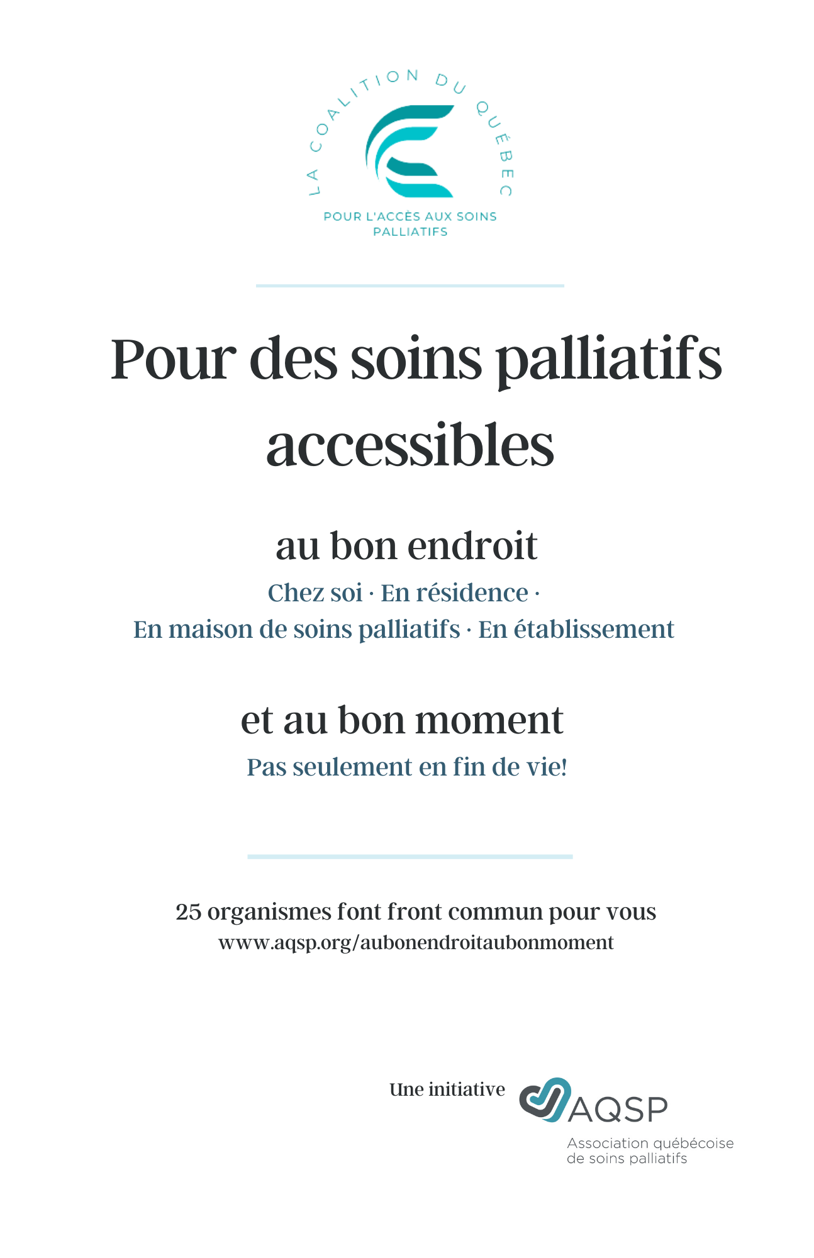

The campaign tools launched for the National Hospice Palliative Care Week in May 2022 are available on this page :
www.aqsp.org/aubonendroitaubonmoment.

The list comprising of the 25 member organizations of the Coalition can also be found on this page: www.aqsp.org/coalition.

VIDEO PRODUCTIONS
The treasure of palliative care
As our previous annual report discussed the production of The Treasure of Palliative Care series, we will only discuss the broadcast of the series here.

After a pre-launch on August 9th, 2021 to allow members of the Quebec Special Committee on the Evolution of the End-of-Life Care Act to get aquainted with the series, it was officially shared one month later, on September 9th, 2021.

We have received several very positive responses to the series. Among the most appreciated shares were those from the European Institute of Bioethics
https://www.ieb-eib.org/fr/actualite/fin-de-vie/euthanasie-et-suicide-assiste/le-tresor-des-soins-palliatifs-encore-si-meconnu-2036.html
and the Association des retraitées et retraités de l'éducation et des autres services publics du Québec
https://areq.lacsq.org/le-tresor-des-soins-palliatifs-six-questions-essentielles/2021/09

The two most popular videos in the series:
In French, 3,200 views of the video Le trésor des soins palliatifs on YouTube.
In English, 13,058 (!) views of the video Does morphine cause death? on YouTube.
The full series is still available via vivredignite.org/treasure and LWD's social networks.

Expanding medical aid in dying?

One of the most important Quebec thinkers on the subject of medical aid in dying is without a doubt philosophy professor and author Louis-André Richard. An expert in ethical and political philosophy, he has been providing training in palliative care in Quebec and France for over 15 years. He participated in the development of Bill 52 (Quebec law on end-of-life care) from 2010. He holds a doctorate in philosophy, palliative culture and society.

In November 2021, Mr. Richard generously opened the door to his Quebec City condominium for a full afternoon with videographer Bruno Olivier and our coordinator Jasmin Lemieux-Lefebvre.

A series of seven video vignettes entitled "Expanding Medical Aid in Dying?" was born out of the hours spent with him. Short versions were posted on Facebook and longer versions on YouTube.

To maximize their impact, we shared these videos in three stages:

On December 8th, 2021, the day the Quebec Special Committee report was tabled, we published the videos entitled:
- Before expanding access to medical aid in dying in Quebec
- Should medical aid in dying for mental disorders be regulated?
- Advance directives and end-of-life realities

On April 13th, 2022, the day the AMAD Federal Committee began its work, we shared:

- Peaceful death and death in peace

On May 25th, 2022, the day Bill 38 was introduced, the last three videos in the series were released:

- Living and dying with dignity
- The apparent unanimity
- The law of the stork

To view the entire series, in French:
Long versions (YouTube playlist)
Short version (Facebook playlist)

Incapable of dying by advance directives

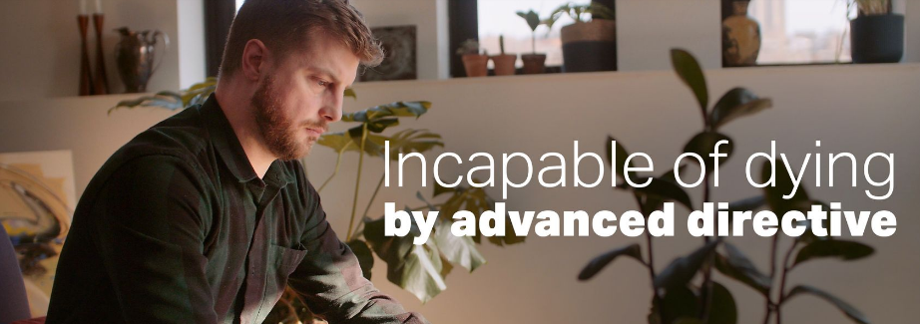
As the Quebec Bill, which included medical aid in dying by advance directives, loomed on the horizon, we met with the leading figure among Quebec experts opposed to the idea, geriatrician Félix Pageau. He is the author of the book "La responsabilité de protéger les personnes âgées atteintes de démence. Manifesto" published by Laval University Press.

Eight short videos were created, four in French and four in English:
- Loss of capacity: care is available
- The mirage of autonomy
- Happy dementia is possible
- Real care for people incapable of decision-making
As we mentioned in the Provincial Political Scene section, we shared the series at the time that the MLAs studying Bill 38 declined to invite Dr. Pageau. While we would have preferred that the broadcast of this series support his testimony in court, we were proud that the videos could at least make his views on the potential expansion of MAiD readily available.

To view the entire series:
French version (YouTube playlist, Facebook playlist)
English version (YouTube playlist, Facebook playlist)

ONLINE PRESENCE
In another year marked by the Covid-19 pandemic, our on-line efforts continued to reach a wider audience. The following is a summary of our key actions.

Website

We maintain an updated website vivredignite.org/en, in French and English. We published 20 articles in French and 12 in English for a total of 32 this year. In addition to sharing our news releases, briefs and newsletters, we keep the public informed of the most important news on pertinent topics.

Send by email

We sent out 24 mass e-mailings this year (12 in French, 12 in English). Once again, we focused on Calls to Action rather than Newsletters (3 in each language, in November, December and March).
Social Media
As mentioned in the introduction of this section, we have identified the need to make greater use of social networks to interact with our allies, but also with journalists, politicians and sometimes, our opponents.
Here are some statistics on our use of these great communication tools:

Twitter
512 subscribers (including several journalists, politicians and opinion leaders).

The numbers in brackets (x, y, z) refer to the mode of communication, i.e. an original publication (x), a retweet/republication of an external publication (y) or a response (z).
June 2021: FR 12 tweets (6, 3, 4) + EN 3 tweets (2, 1, 0) = 15
August 2021: FR 20 tweets (15, 4, 1) = 20
September 2021: FR 15 tweets (10, 5, 0) + EN 3 tweets (3, 0, 0) = 18
October 2021: EN 11 tweets (5, 5, 1) = 11
November 2021: FR 14 tweets (10, 3, 1) + EN 2 tweets (2, 0, 0) = 16
December 2021: FR 37 tweets (22, 12, 3) + EN 1 tweets (1,0, 0) = 38
January 2022: FR 13 tweets (10, 3, 0) = 13
February 2022: FR 13 tweets (6, 7, 0) = 13
March 2022: FR 23 tweets (16, 7, 0) + EN 4 tweets (4, 0, 0) = 27
April 2022: FR 25 tweets (17, 6, 2) + EN 12 tweets (7, 4, 1) = 37
May 2022: FR 77 tweets (52, 20, 5) + EN 27 tweets (8, 19, 0) = 104
Number of tweets: 312
Our most popular tweet with 5,469 impressions, published in English on December 8, 2021:

In second place with 3,326 impressions, this tweet published in English on March 3, 2022
Facebook

849 "Likes", 902 accounts follow the page
In parentheses (x, y, z), publications in French (x), English (y) and bilingual (z).
June 2021: 9 publications (8, 1, 0)
August 2021: 12 publications (12, 0, 0)
September 2021: 8 publications (6, 2, 10)
October 2021: 5 publications (5, 0, 0)
November 2021: 7 publications (6, 1, 0)
December 2021: 17 publications (16, 1, 0)
January 2022: 8 publications (8, 0, 0)
February 2022: 7 publications (7, 0, 0)
March 2022: 13 publications (11, 2, 0)
April 2022: 17 publications (14, 3, 0)
May 2022: 29 publications (22, 7, 0)
Total: 132 publications

Our most popular Facebook posts of the year:
5495 users reached following our reaction to Bill 38 on May 25th, 2021

2559 users reached by the testimony Living and loving with Alzheimer's
As usual, these statistics do not include our many interventions in the comments section of media articles about palliative care or MAiD. We make a point of following up on notifications to these publications to respond to those who challenge us publicly or in private messages.

We always pay special attention to the tone of our public speeches. In this way we can relate even to individuals and groups who do not share our opinions. An example among many others, the sharing and response on November 13th, 2021 of Mrs. Sandra Demontigny, spokesperson for the Association for the Right to Die with Dignity, herself an patient with early onset Alzheimer's.

MEDIA
Living with Dignity shared four media releases in the past year:
- September 9, 2021 - The Treasure of Palliative Care on Video
https://vivredignite.org/sites/vivredignite.org/wp-content/uploads/Press-release-The-Treasure-of-Palliative-Care-international-2.pdf
- December 8th, 2021 - Gratitude and Concern - Response to the Report of the Select Committee on the Evolution of the Act respecting end-of-life care
https://vivredignite.org/gratitude-and-concern

- April 13th, 2022 - Our reaction to the multiple initiatives to expand access to medical aid in dying
https://vivredignite.org/peaceful-death-and-death-in-peace

- May 25th, 2022 - Our reaction to the introduction of Bill 38 in Quebec City
https://vivredignite.org/reaction-bill-38

Since the legalization of medical aid in dying in Canada, the media has not asked us for interviews after our Press Releases.
We are happy to have broken this wall of silence twice, with interviews given by our coordinator on the LCN television news channel:

- December 12th, 2021 - Interview with Chu Anh Pham https://www.tvanouvelles.ca/videos/6286359421001

- May 29th, 2022 - Interview with Frédérique Guay https://www.tvanouvelles.ca/videos/6306970598112
In its winter 2022 edition, the magazine Paraquad of Moelle épinière et motricité Québec (The organization aimed at intervening to facilitate the social integration of people with spinal cord injury, to promote their rights and support research) published a feature on medical aid in dying. Our coordinator participated in a two-page interview that can be found on our website https://vivredignite.org/2022/02/vdd-paraquad-hiver-2022
After the success of our media operations last year, we have resumed accompanying people who offer strong testimonies about medical aid in dying and the end-of-life.
Here are two examples of these interventions.
a) During the work of the Select Committee on the Evolution of the Act respecting end-of-life care, we worked closely with Ms. Julie Senécal, see the Provincial political scene section. In order to make her testimony more visible, we assisted her in publishing an open letter via many media avenues:
All digital versions of Quebecor media (Journal de Québec, Journal de Montréal, TVA News) https://www.tvanouvelles.ca/2021/08/17/sante-mentale-et-aide-medicale-a-mourir-une-situation-complexe
Metro Newspaper
https://journalmetro.com/debats/2680328/le-manque-flagrant-des- HYPERLINK "https://journalmetro.com/debats/2680328/le-manque-flagrant-des-ressources-en-sante-mentale-et-laide-medicale-a-mourir"ressources-en-sante-mentale-et-laide-medicale-a-mourir
The daily newspapers of the Information Coop, including Le Soleil
https://www.lesoleil.com/2021/08/12/manque-de-ressources-en-sante-mentale-et-en-aide-a-mourir-ff256365fbf5d130de23da83e15f4d8b
This publication made possible an interview with Sophie Durocher on QUB Radio (broken link, screenshot still available on our social networks).
b) In January 2021, our press review allowed us to discover the testimony of Mr. Sylvain Dufour, a caregiver living in Abitibi with his mother Carmen, whom he accompanies with great care. Since his admirable story was shared only in his region, we invited him to write an open letter that was published in La Presse+ under the title Vivre et aimer avec l'Alzheimer.

In his text, Mr. Dufour concretely opposes the idea of extending medical aid in dying to people like his mother. We have put all the hyperlinks of this media coverage on this page: https://vivredignite.org/2022/01/vivre-et-aimer-avec-lalzheimer.
Excerpts:
In 2021, there was a lot of talk about Alzheimer's disease in Quebec. Unfortunately, most of the time, it was approached from the angle of an inexorable "decline" at the end of life. How can we not fear this situation as it is presented to us? It is not surprising that, in this context, the Quebec government is planning to introduce a Bill opening the door to advance directives to offer medical aid in dying to people with neurocognitive disorders who have become incapacitated. Far from rejoicing, this idea anguishes me. The message it sends? It would be better to consider dying than to live with advanced Alzheimer's disease.
(...)
Speaking of his mom - If she had been offered to ask for medical aid in dying by advance directive when she was still able, I wouldn't have known what to do.
I think she would have been confused too. I suspect her answer would have been no. But if she had witnessed the media hype of the last few months, which makes us fear the worst, I don't know.
If the law had allowed it three and a half years ago, and my mother had decided to sign an advance directive naming me as a trusted third party, I could now trigger the process that would bring about her death. My mother's death... She who is happy, who loves many people and is loved in return. It is true that she is not aware of everything, but she loves life to the core.

FUTURE PROSPECTS

Three events will mark the coming year:

- December 2022: Probable introduction of a revised version of Bill 38 amending the "An Act respecting end-of-life care and other legislative provisions."
- February 17th, 2023: New deadline for the report of the Special Joint Committee on Medical Aid in Dying

- March 7th, 2023: Unless deferred, eligibility for MAiD for individuals with mental illness as the sole underlying medical condition

We must be prepared to present firm and respectful opposition to each of these attempts to extend access to MAiD to groups of people who are suffering and who need medical assistance to live rather than to die.

As the issue of euthanasia is raised in new jurisdictions around the world each year, we are pleased to be a part of this global network of groups that are standing up to deny the practice as a societal advancement.
Quebec and Canada must not serve as a locomotive or inspiration to other nations and Living with Dignity will likely be called upon to bear witness internationally. The model chosen by our province and our country, that of making euthanasia an ever more accessible form of care out of supposed compassion, is a dangerous avenue to avoid. We are pleased to see that opposition is not limited to one political stream or another. Groups and individuals on both the left and the right are becoming aware of the reality of the dangers of the slippery slope for our societies and for living together. As ethicist Margaret Somerville said in February 2022 in Inflicting Death Becomes Routine when Euthanasia is Legal: "Some essential experiences of life cannot be compressed in time without destroying their essence, and what we can give and receive, as well as learn, in these situations. Natural death is one of those experiences." This conviction drives us. It drives us to continue our mission despite the headwinds. To walk with those who want to remind the world of the dignity of all human beings, at every stage of their lives and until their natural death.

